**22107671 BU JIAQI**

**Because the file is too big, I sent it to you by email.**

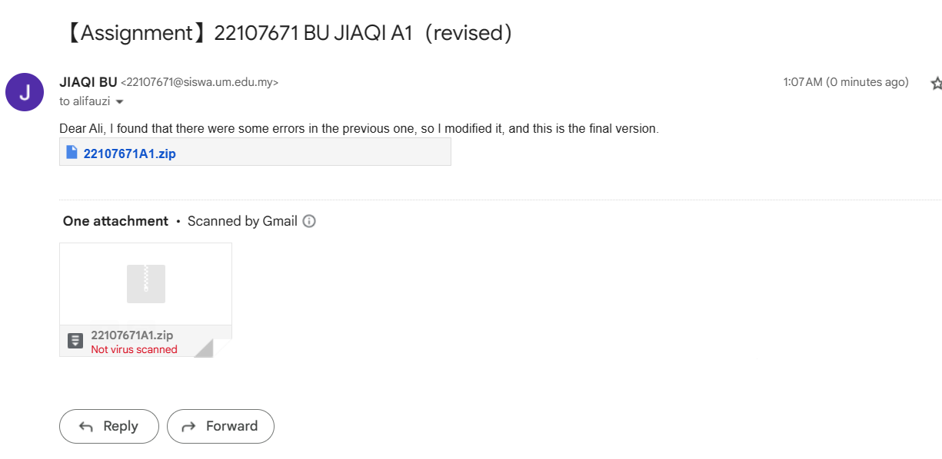

1. Add bold and italic words to your document.

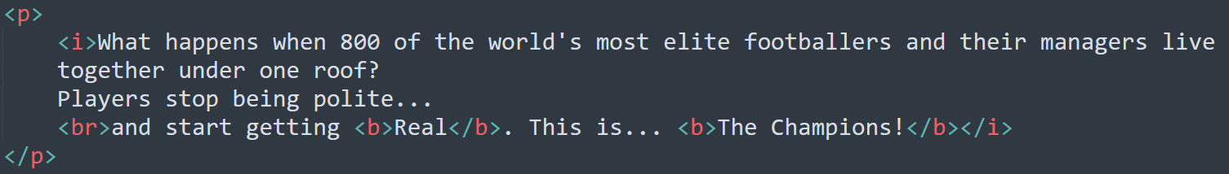



1. Add a header to your document.

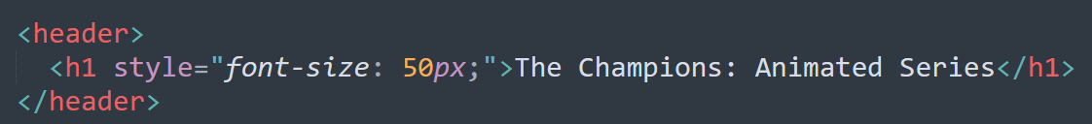



1. Add paragraph and break tags to your document.





1. Add a horizontal rule where appropriate.

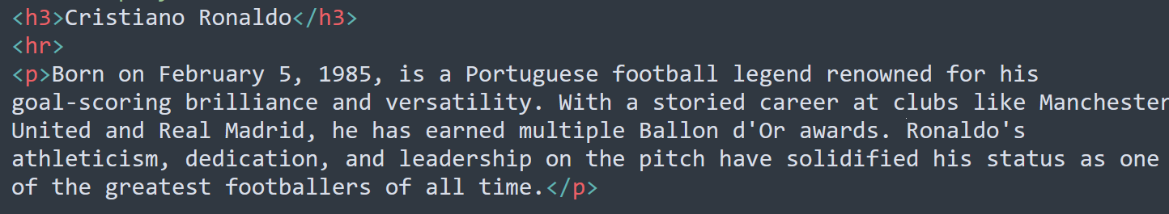



1. Add a list to your document.

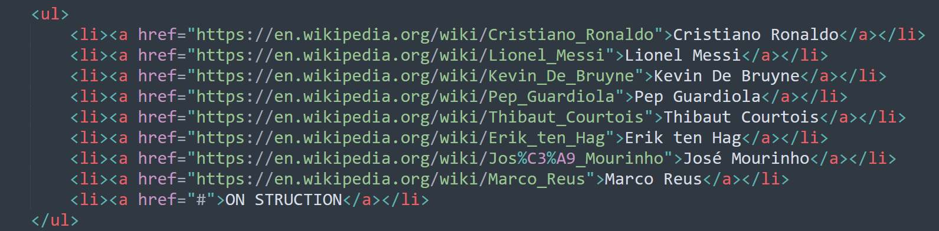

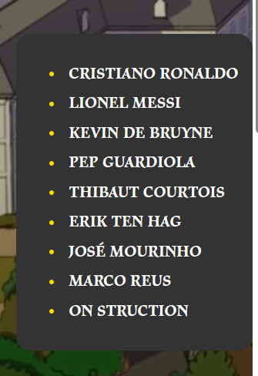

1. Add images to your document.

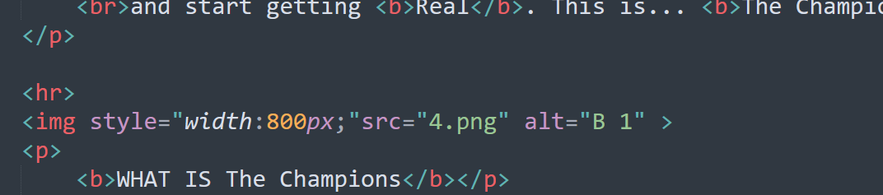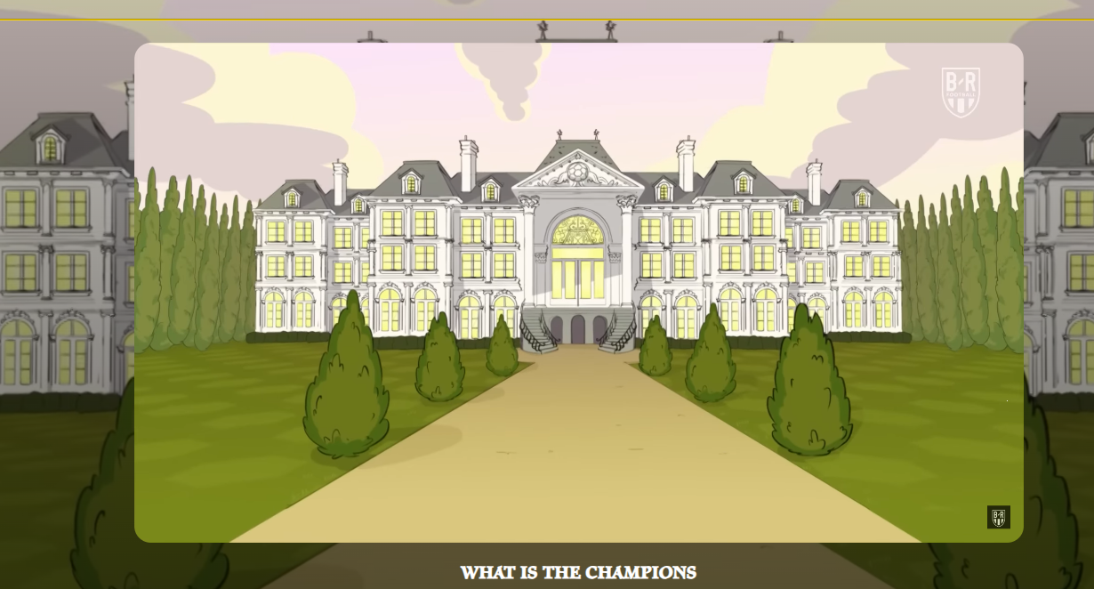

1. Add a table to your document.

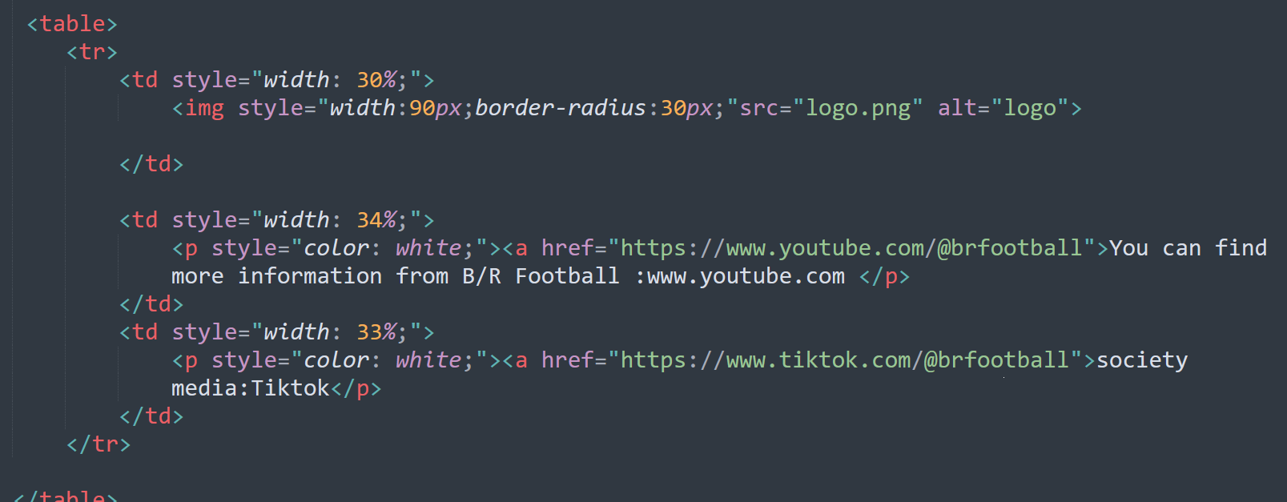

1. Create a link to an online webpage/store.

